Google Play Store Apps Analysis & User Review Sentiment Study
Name: Samskrithi S
Internship Project: Data Analytics
Dataset: Google Play Store Apps & User Reviews
Tools Used: Python, Pandas, Matplotlib, Seaborn, Jupyter Notebook

1. Introduction
The Google Play Store is one of the largest digital marketplaces, hosting millions of mobile applications across diverse categories. With increasing competition among developers, understanding factors such as app ratings, installs, pricing models, and user feedback has become crucial for building successful applications.
This project focuses on analysing Google Play Store application data along with user reviews to uncover meaningful patterns related to app performance and user satisfaction. By transforming raw transactional and textual data into insights, the study aims to support data-driven decision-making for app developers, marketers, and business stakeholders.

2. Objectives of the Study
The primary objectives of this project are:
- To analyse the distribution of applications across different categories
- To study rating patterns and factors influencing app popularity
- To compare free and paid applications based on installs and ratings
- To examine install trends and pricing behaviour
- To perform sentiment analysis on user reviews to understand customer perception

3. Dataset Description
Two datasets were used in this analysis:
3.1 Google Play Store Apps Dataset
- Contains 10,841 applications with 13 attributes
- Key columns include:
  - App, Category, Rating, Reviews, Size, Installs, Type, Price, Content Rating, Genres, Last Updated
3.2 User Reviews Dataset
- Contains 64,295 user reviews
- Key columns include:
  - App, Translated_Review, Sentiment, Sentiment_Polarity, Sentiment_Subjectivity
Some columns contained missing or inconsistent values, which were addressed during data preprocessing.

4. Data Cleaning and Preprocessing
To ensure reliable analysis, the following preprocessing steps were performed:
- Converted Reviews, Installs, and Price into numeric formats
- Cleaned the Size column by standardising values into megabytes
- Handled missing ratings and invalid entries
- Converted date fields into proper datetime format
- Removed duplicate and inconsistent records where necessary
These steps improved data quality and ensured smooth exploratory analysis.

5. Exploratory Data Analysis (EDA)
Exploratory Data Analysis was conducted to understand trends, distributions, and relationships within the dataset.
5.1 App Category Distribution
The Play Store is dominated by categories such as Family, Game, and Tools, indicating high competition in these segments.
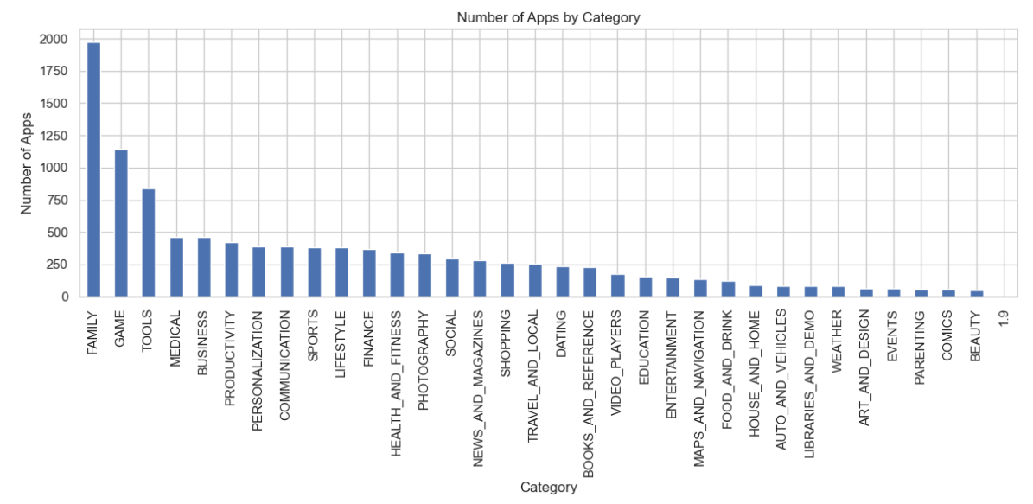

5.2 Rating Distribution
Most applications have ratings between 4.0 and 4.5, suggesting generally positive user feedback. However, a noticeable number of apps lack ratings, often due to low engagement.
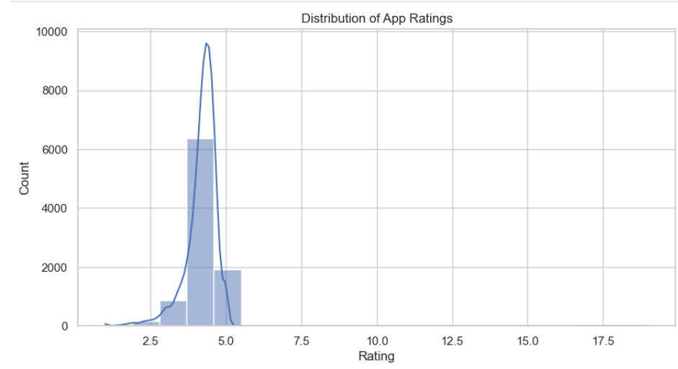

5.3 Free vs Paid Applications
Free apps significantly outnumber paid apps and receive far higher install counts. However, paid apps tend to have slightly better average ratings, reflecting perceived quality.
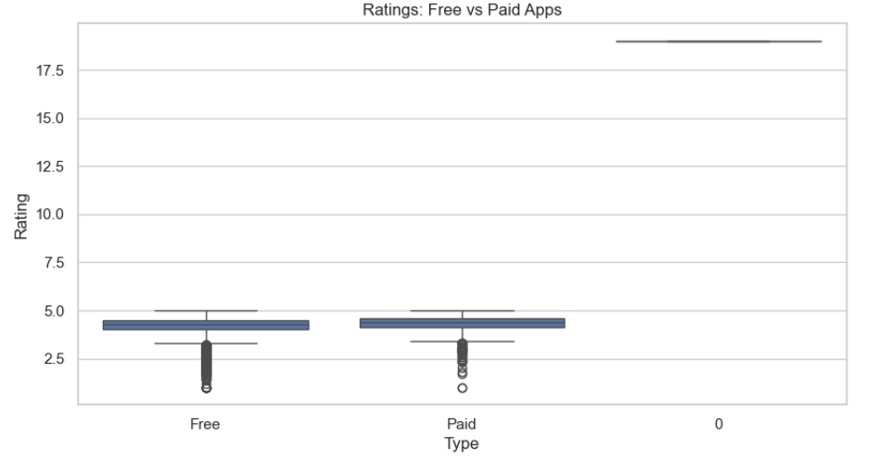

5.4 Installs vs Ratings
Applications with higher install counts generally maintain stable ratings, indicating trust and consistent user experience among popular apps.
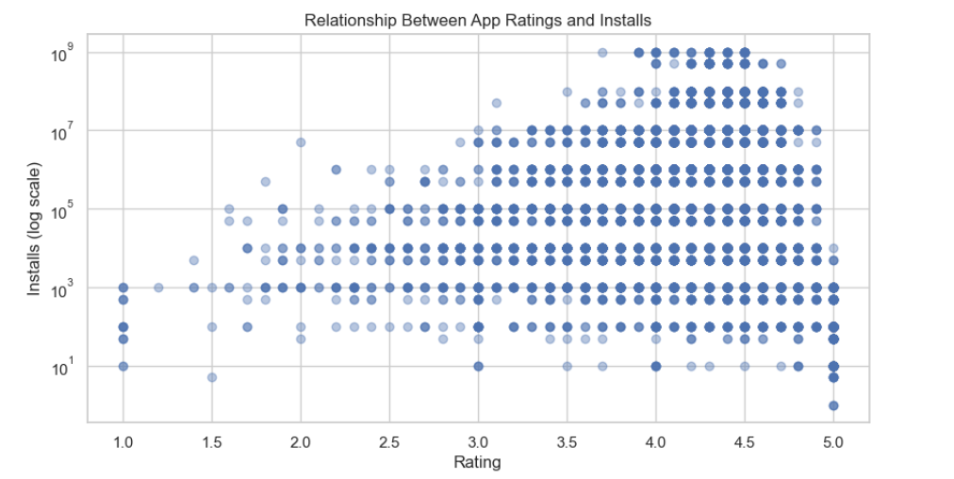

5.5 Content Rating Analysis
Most apps are rated Everyone, showing that developers largely target a general audience.
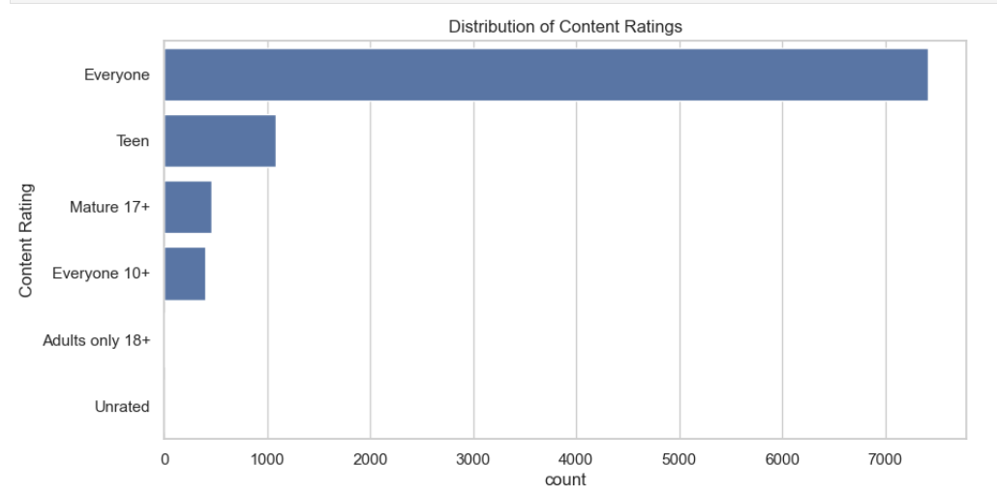

6. Sentiment Analysis of User Reviews
Sentiment analysis was performed on user reviews to understand customer opinions. Reviews were categorised into Positive, Neutral, and Negative sentiments using polarity scores.
The results show that:
- Positive sentiment dominates the dataset
- Negative reviews highlight usability issues, bugs, and performance concerns
- Neutral reviews are typically descriptive without strong emotional tone
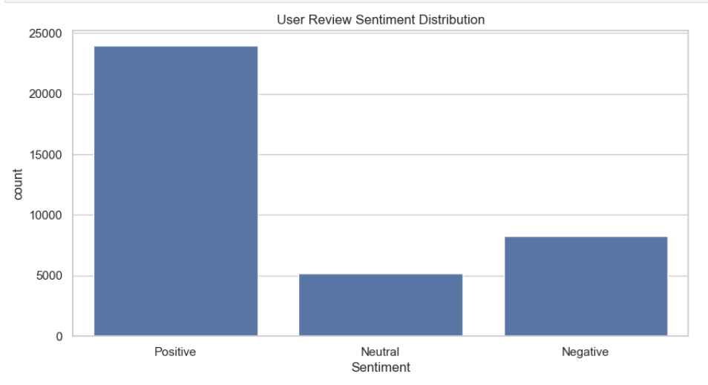

7. Key Insights and Findings
- Free apps dominate the Play Store in terms of availability and installs
- Paid apps generally achieve slightly higher average ratings
- Certain categories are highly saturated, increasing competition
- Apps with consistent updates tend to receive better user feedback
- Overall user sentiment towards Play Store apps is largely positive

